CampusFix
Software Requirements Specification (SRS)
Course: Software Engineering
Instructor: Sir Jahanzaib Ahmed Khan

Group Members:
Muhammad Azam (IU05-0124-0190)
Kashif Raza (IU05-0124-0303)
Tehreem Aijaz (IU05-0124-0126)

1. Introduction

1.1 Purpose
This Software Requirements Specification describes the requirements, assumptions, users, features, interfaces, constraints and acceptance criteria for CampusFix. It is written for the course instructor, project team and future developers who may review or extend the system.

1.2 Document Conventions
Functional requirements are labeled as FR-01, FR-02 and so on. Non-functional requirements are labeled as NFR-01 and onwards. The word shall indicates a required system behavior.

1.3 Intended Audience
- Course instructor and evaluator
- Project team members
- Students presenting the system in viva
- Future developer maintaining the project

1.4 Product Scope
CampusFix is a local desktop system for submitting, tracking and managing campus maintenance complaints. It is meant for small campus-level use and academic demonstration.

1.5 References
Python official documentation, Tkinter documentation, SQLite documentation and standard IEEE-style SRS structure were used as general references while preparing this document.

2. Overall Description

2.1 Product Perspective
CampusFix is a stand-alone desktop application. It does not depend on a web server. It stores data in a local SQLite database file and uses a Tkinter graphical user interface.

2.2 Product Functions
- User registration and login
- Role-based dashboard display
- Complaint creation with category, location and priority
- User complaint tracking
- Admin complaint filtering and search
- Complaint assignment and status update
- Dashboard counts for total, open, resolved and urgent complaints

2.3 User Classes and Characteristics
User Class | Description | Skill Level
Student/Staff User | Submits and tracks complaints | Basic computer usage
Admin/Maintenance User | Reviews complaints and updates progress | Basic to moderate computer usage

2.4 Operating Environment
Item | Requirement
Operating System | Windows, Linux or macOS with Python installed
Runtime | Python 3.x
Database | SQLite local database file
Display | Desktop or laptop screen suitable for Tkinter GUI

2.5 Design and Implementation Constraints
- The system uses Tkinter to avoid external GUI dependencies.
- The database is local SQLite, so multi-device simultaneous access is outside scope.
- The application is designed for a semester project and not for production deployment.

2.6 Assumptions and Dependencies
- Users will run the application on a computer with Python installed.
- The admin account will be available for demonstration.
- The local database file will remain in the project src folder unless the configuration is changed.

3. SDLC Model
The project uses the Iterative and Incremental Model. The reason for using this model is that CampusFix can be divided into small working increments: authentication, user complaint entry, admin complaint management, dashboard statistics and testing. After each increment, the team can run the application, check the screen behavior and improve the next part. This model is suitable because it reduces risk and gives visible progress during a semester project.

4. System Features and Functional Requirements
ID | Requirement | Detailed Description
FR-01 | User Registration | The system shall allow new student/staff users to create an account with name, email and password.
FR-02 | Login | The system shall authenticate users and open the correct dashboard based on role.
FR-03 | Submit Complaint | A user shall submit a complaint with title, category, location, priority and description.
FR-04 | Track Complaints | A user shall view his or her complaint history and current status.
FR-05 | Admin View | An admin shall view all submitted complaints in one dashboard.
FR-06 | Search and Filter | An admin shall filter complaints by status and search by title, reporter, category or complaint ID.
FR-07 | Assign Complaint | An admin shall assign a complaint to a staff member or technician.
FR-08 | Update Status | An admin shall update the status as Submitted, Assigned, In Progress, Resolved or Closed.
FR-09 | Dashboard Counts | The system shall display total, open, resolved and urgent complaint counts.

5. External Interface Requirements

5.1 User Interface
The GUI shall provide separate views for login/registration, user dashboard and admin dashboard. Tables shall be used to display complaint records. Input fields shall be clearly labeled.

5.2 Software Interfaces
The application shall interact with SQLite through the database module. The GUI module shall call database functions instead of directly writing SQL inside button events where possible.

5.3 Hardware Interfaces
No special hardware is required. A standard desktop or laptop computer is sufficient.

5.4 Communication Interfaces
No internet or network communication is required in the current version.

6. Non-Functional Requirements
ID | Quality Attribute | Requirement
NFR-01 | Usability | The interface should be simple enough for a first-time user to submit a complaint without training.
NFR-02 | Reliability | SQLite foreign keys and required fields should protect the basic consistency of complaint records.
NFR-03 | Performance | Common dashboard operations should respond quickly for a small campus dataset.
NFR-04 | Maintainability | The code should keep GUI, configuration and database functions separate.
NFR-05 | Security | Passwords are not stored directly; the project stores SHA-256 password hashes for demonstration.

7. Data Requirements
Entity | Attributes | Notes
User | id, full_name, email, password_hash, role, created_at | Email must be unique. Role controls the dashboard.
Complaint | id, user_id, title, category, location, priority, description, status, assigned_to, admin_note, created_at, updated_at | Complaint belongs to one user and can be updated by admin.

8. Diagrams

8.1 Use Case Diagram
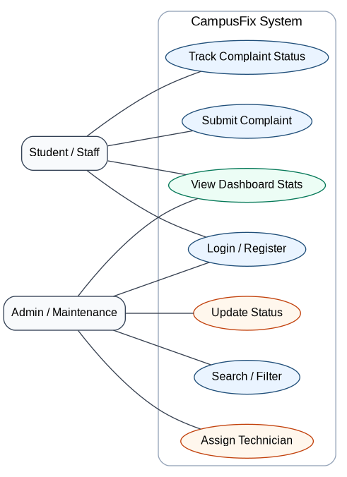
Use case diagram for CampusFix.

8.2 Class Diagram
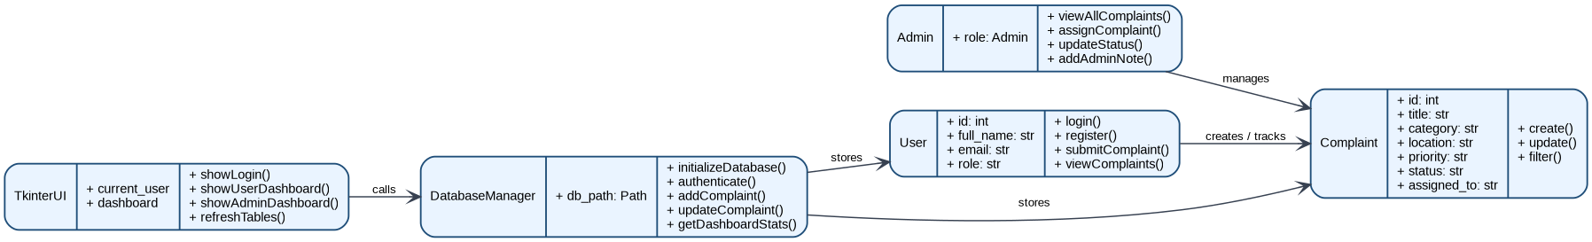
Class/module diagram for CampusFix.

8.3 Activity Diagram
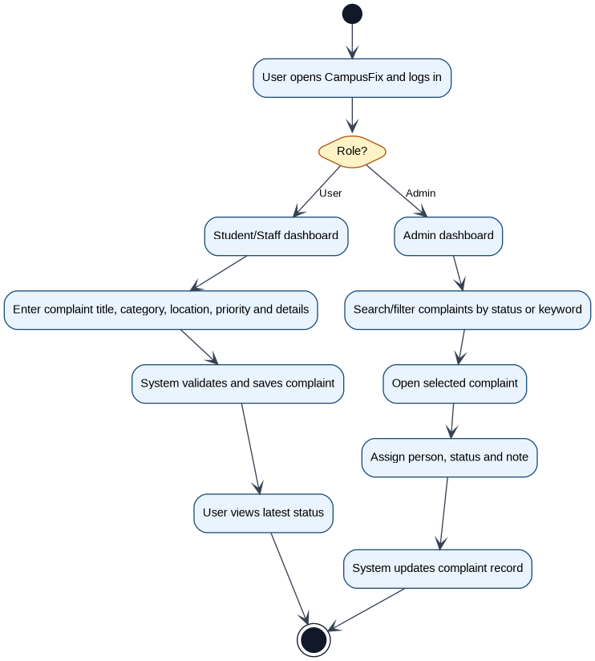
Activity diagram for complaint submission and management.

8.4 Sequence Diagram
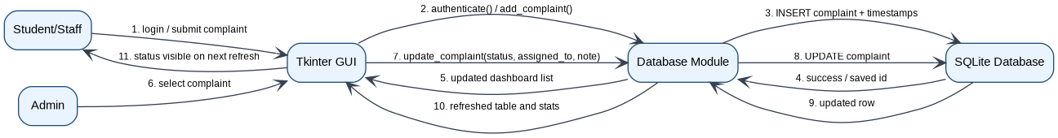
Sequence diagram for complaint life cycle.

8.5 UML Component Diagram
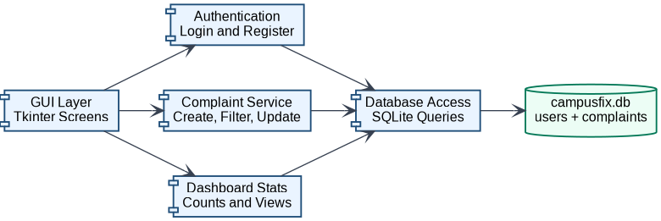
UML component diagram of the system layers.

8.6 Entity Relationship Diagram
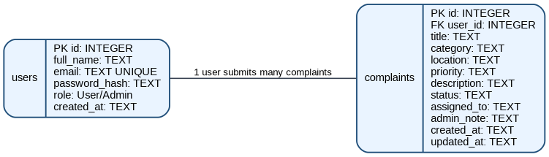
ERD showing users and complaints tables.

9. Use Case Specifications
Use Case | Primary Actor | Precondition | Main Flow | Postcondition
UC-01 Register Account | Student/Staff | User is not registered | Enter name, email and password, then submit form | New user account is saved
UC-02 Submit Complaint | Student/Staff | User is logged in | Fill complaint form and press submit | Complaint is saved with Submitted status
UC-03 Track Complaint | Student/Staff | User has complaints | Open dashboard complaint table | User sees current status
UC-04 Manage Complaint | Admin | Admin is logged in | Search/select complaint, set status, assign staff and save note | Complaint record is updated

10. Acceptance Criteria
- A new user can register and log in successfully.
- A user can submit a complaint and see it in the complaint table.
- An admin can view all complaints and filter by status.
- An admin can update the status, assignment and notes of a complaint.
- The dashboard statistics change according to database records.
- The application can be run from the included project files without a complex installation process.

11. Requirement Traceability Matrix
Requirement | Design Element | Test Case
FR-01 | Registration form and users table | TC-02
FR-02 | Login screen and authenticate function | TC-01
FR-03 | Complaint form and complaints table | TC-03
FR-06 | Admin table search/filter controls | TC-04
FR-07/FR-08 | Admin update panel and update_complaint function | TC-05
FR-09 | Dashboard stats function | TC-06

12. Future Requirements
Future versions may include web access, email notifications, image attachments, technician accounts, complaint SLA reports and role management. These features are intentionally not included in the first version to keep the project focused and presentable.

